# 

#### 

II

Abstract

In this project we propose catering ordering system. It involves a lot of human work and the resources required. So managing of the resources and the people will become difficult. To solve these problems, the catering ordering system will be of great help. There are different kinds of catering like mobile catering, wedding catering, catering on ships and so on. The catering ordering system will help in maintaining the available people, resources and the timings well. It will help in the solving the problems related to the catering at the events that are conducted. Nowadays, many people using catering service for the event purpose. But it is difficult for some people to find the best catering that provide special type kind of food. The problem to find the best catering services is time consuming and making the right choices is difficult. Hence, Catering Ordering System help the users to make a better choice to select appropriate caterers based on user requirement. This is a web-based system that allows users to find the best catering service pricing which is applied Selection Sorting Algorithm to perform this task. This algorithm not depends on the initial order of the data. Therefore, customers can choose catering menu services that appear according with inputs of various prices by the customers. Therefore, it is easier for customers to booking online and this can save the time, cost and appropriate information of caterers. In addition it also helps in solving the problems of the selection catering services based on their budget estimates.

III

**TABLE OF CONTENTS**

|  |  |  |
| --- | --- | --- |
| **Sl No** | **Chapter** | **Page No** |
| 1. | Introduction | 1-2 |
| 1.1 Introduction to the topic |
| 1.1.1 Problem Identification |
| 1.1.2 Problem Identification |
| 1.1.3 Proposed System |
| 1.1.4 Advantages Of Proposed System |
| 1.2 Company Introduction |
| 1.2.1 About Department |
| 2. | Training Program | 03 |
| 3. | Learning Experience | 04-05 |
| 4. | Strength, Weakness, Opportunities, Threats (SWOT) Analysis | 06-07 |
| 5. | Implementation | 08-14 |
| 5.1 Problem Statement |
| 5.1.1 Dataset |
| 5.1.2 Variable Information |
| 5.2 Algorithm |
| 5.2.1 Selection sort algorithm |
| 5.3 Code |
| 6. | Results | 15-17 |
| 7. | Conclusion And Future Enhancements | 18 |
|  | Bibliography | 19 |

IV

### LIST OF FIGURES

|  |  |  |
| --- | --- | --- |
| **SL No.** | **Description** | **Page no** |
| **1** | Fig 1: Department Of SystemTron company | **02** |
| **2** | Fig 5.1: Overview Of Dataset | **08** |

**LIST OF SCREENSHOTS**

|  |  |  |
| --- | --- | --- |
| **SL No** | **Description** | **Page no** |
| **1** | Screenshot 6.1: Admin Register page | **15** |
| **2** | Screenshot 6.2: Admin Login page | **15** |
| **3** | Screenshot 6.3: User menu | **16** |
| **4** | Screenshot 6.4: User order page | **16** |
| **5** | Screenshot 6.5: User Contact to admin | **16** |
| **6** | Screenshot 6.6: Admin messages | **17** |
| **7** | Screenshot 6.7: Admin received orders | **17** |

V

**WEEKLY OVERVIEW OF INTERNSHIP ACTIVITIES**

|  |  |  |  |
| --- | --- | --- | --- |
| W E E K  1 | **DATE** | **DAY** | **NAME OF THE TOPIC/MODULE COMPLETED** |
| 25/10/2023 | WEDNESDAY | Introduction |
| 26/10/2023 | THURSDAY | Introduction to HTML |
| 27/10/2023 | FRIDAY | HTML practice and project application |
| 30/10/2023 | MONDAY | Introduction to CSS and CSS practice |
| 31/10/2023 | TUESDAY | Task 1: Simple Calculator |

|  |  |  |  |
| --- | --- | --- | --- |
| W E E K  2 | **DATE** | **DAY** | **NAME OF THE TOPIC/MODULE COMPLETED** |
| 01/11/2023 | WEDNESDAY | Introduction to JavaScripts |
| 02/11/2023 | THURSDAY | Basics Of JS - l |
| 03/11/2023 | FRIDAY | Basics Of JS – l1 |
| 06/11/2023 | MONDAY | JS practice and project application |
| 07/11/2023 | TUESDAY | TASK 2: TO-DO List App |

VI

|  |  |  |  |  |
| --- | --- | --- | --- | --- |
|  | W E E K  3 | **DATE** | **DAY** | **NAME OF THE TOPIC/MODULE** |
|  |  | **COMPLETED** |
| 08/11/2023 | WEDNESDAY | Introduction to PHP |
|  |  |  |
|  |  |  |
| 09/11/2023 | THURSDAY | PHP and MySQL integration |
|  |  |  |
| 13/11/2023 | MONDAY | CRUD operations with PHP and MySQL |
| 14/11/2023 | TUESDAY | User authentication implementation |
| 15/11/2023 | WEDNESDAY | Task 3: Netflix Clone Wedsite |

|  |  |  |  |
| --- | --- | --- | --- |
| W E E K  4 | **DATE** | **DAY** | **NAME OF THE TOPIC/MODULE COMPLETED** |
| 16/11/2023 | THURSDAY | Advanced Features and Deployment |
| 20/11/2023 | MONDAY | Performance optimization techniques |
| 21/11/2023 | TUESDAY | Testing and debugging |
| 22/11/2023 | WEDNESDAY | Final project review and deployment |
| 24/11/2021 | FRIDAY | Task 4: Memory matching game |

VII

**CHAPTER 1**

**INTRODUCTION**

* 1. **INTRODUCTION TO TOPIC**

### Purpose of the project

Customers can place orders online, and the system organizes these orders for the catering service provider. Customers can specify dietary requirements, portion sizes, delivery preferences, and any special instructions through the system, ensuring their orders meet their specific needs.

### Problem Identification

The catering ordering system is experiencing inefficiencies and errors, resulting in delayed order processing, inaccurate order fulfillment, and dissatisfied customers. The current system lacks automation, relying on manual data entry and sorting, leading to increased labor costs and potential for human error. Additionally, the system fails to provide real-time order tracking, resulting in poor communication and misunderstandings with customers. Furthermore, the system lacks integration with inventory management, leading to stockouts and overstocking of menu items.

### Proposed System

An online food ordering system based on the Internet of Things is suggested to get beyond the limitations of the aforementioned method. As Android devices have grown in popularity in the automation of normal tasks in wireless environments, the usage of mobile technology has undergone a revolution. Android is an operating system made for mobile devices like smartphones and tablets. The study's overall goal is to create a dependable, practical, and accurate food ordering system.

### 1.1.3 Advantages of Proposed System

A method that will undoubtedly satisfy customer service will be taken into consideration as an objective. Customers can place orders online from anywhere at any time, reducing the need to visit or call the catering service during specific hours. This convenience enhances customer satisfaction and loyalty. Ordering through the system saves time for both customers and catering staff. Automates the ordering process, reducing manual errors and streamlining operations. Enables customers to place orders anytime, anywhere, improving accessibility and satisfaction.

* 1. **COMPANY INTRODUCTION**

SystemTron Company established in 2022.At System Tron, is not just a company; your trusted partners in innovation, dedicated to shaping a brighter future through cutting-edge technology solutions. System Tron, is gateway to exciting engineering internships and training opportunities. Whether engineering, MCA, or BCA student, they have the resources to help you kickstart career in the tech industry.

The technology company on a mission to equip students with relevant skills & practical exposure to help them get the best possible start to their careers. Imagine a world full of freedom and possibilities. A world where you can discover your passion and turn it into your career. A world where you graduate fully assured, confident, and prepared to stake a claim on your place in the world

### About Department:

At SystemTron, passion for technology fuels our commitment to excellence. With a team of industry-leading experts, they're driven to empower our success by providing top-notch solutions, support, and guidance. Join System Tron in forging the path to a dynamic and transformative future. SystemTron is committed to provide unbeatable value for every assignment. Our Solutions address not just the immediate but also the holistic needs of any organization which are Culture, Cost and Profitability. Our Recruitment Strategy is based on providing the right career to every candidate based on their individual profile and aptitude. This translates to Passion and Commitment to any role that they are assigned since they are focused on a long term career rather than just a temporary Job.

Figure 1.1: Departments of SystemTron



* Human Resources

Operations

Finanace And Accounting

System Tron

Research And Developme nt

Sales And Marketing

**CHAPTER 2**

**TRAINING PROGRAM**

The training program for managing an Catering ordering system is designed to equip employees with essential skills in HTML, CSS, JavaScript, PHP, and MySQL over a four-week period.

The program begins with an introduction to the online bookstore system, emphasizing the benefits and workflows involved.

In the first week, participants learn the basics of HTML and CSS to create and style web pages.

The second week focuses on JavaScript, teaching employees how to add interactivity and perform form validations.

The third week delves into backend development, covering PHP and MySQL for handling form submissions and database operations.

In the final week, the training addresses advanced topics such as user authentication, security, and order management, culminating in testing and deploying the application to a live server.

Practical sessions throughout the program ensure hands-on experience, while assessments evaluate understanding and application of learned skills. This comprehensive training ensures employees are proficient in both the technical and operational aspects of managing an online bookstore, enabling them to maintain and enhance the platform effectively.

**CHAPTER 3**

## LEARNING EXPERIENCE

##### Knowledge acquired:

* Understanding Customer Needs: Learned to identify and accommodate diverse dietary requirements, preferences for customization, and expectations for service reliability.
* Data Preprocessing and Analysis: Explored techniques for data cleaning, feature engineering, and exploratory data analysis to prepare the data for modeling.
* Model Development: Understood the process of selection-sort model training, hyperparameter tuning, and evaluation metrics like accuracy and sensitivity.

##### Skills learned:

* Data Manipulation: Developed skills in using programming languages to handle and manipulate.
* Database management: Understanding how to design and implement databases to store and manage catering orders, menus, and customer information.
* Model Evaluation: Gained practical experience in evaluating the performance of the selection sort model using appropriate metrics and interpreting the results.
* Technical Report Writing: Enhanced skills in writing technical reports by structuring information, presenting findings clearly, and effectively communicating technical concepts.

##### Observed attitudes and gained values:

* Importance of Interdisciplinary Work: Witnessed the value of collaboration between data science and healthcare professionals for developing impactful solutions.
* Problem-solving: Understanding the value of breaking down complex problems into manageable parts.
* Customer Service: Recognizing the value of timely and accurate order fulfillment.
* Collaboration: Working effectively with team members and stakeholders.

##### The most challenging tasks performed:

* Handling Large Datasets: Catering systems often deal with large volumes of data, including numerous orders, extensive menu items, and varying customer preferences.
* User Interface and Experience: Presenting sorted results intuitively to users, considering usability and accessibility aspects.
* Performance Optimization: Selection sort, while straightforward, may not be the most efficient sorting algorithm for very large datasets or complex sorting requirements.
* Communicating Complex Concepts: Translating technical machine learning concepts into an understandable format for a broader audience required clear and concise communication skills.

**CHAPTER 4**

## STRENGTH, WEAKNESS, OPPORTUNITIES, THREATS (SWOT) ANALYSIS

#### STRENGTH:

* L Accuracy: Selection sort algorithm can achieve good accuracy in classification tasks, especially when dealing with well-defined datasets.
* Interpretability: Selection sort is a straightforward algorithm that is easy to comprehend, even for those without extensive programming knowledge. Its simplicity makes it accessible and interpretable.
* Efficiency: Selection sort algorithm is a relatively simple algorithm with efficient computational requirements, making it suitable for real-time applications.
* Scalability: The system can be potentially scaled to handle larger datasets as more data becomes available.
* Low Training Cost: Selection sort algorithm requires minimal data pre-processing and can be trained with moderate computational resources.

#### WEAKNESS:

* Slow processing: Selection sort's inefficiency can lead to delayed order processing, potentially causing delays in food preparation and delivery.
* Inability to handle priority orders: Selection sort doesn't prioritize orders based on urgency or special requests, which can lead to delays in fulfilling critical orders.
* Inefficient use of resources: The algorithm's inefficiency can result in wasted resources (e.g., labor, equipment) due to delayed or inefficient order processing.
* Scalability issues: As the catering business grows, selection sort's performance may degrade, leading to increased delays and decreased customer satisfaction.
* Lack of adaptability: Selection sort doesn't adapt to changes in ordering patterns or menu items, potentially leading to inefficient sorting and processing.

#### OPPORTUNITIES:

* Simple implementation: Selection sort is easy to implement, allowing for quick integration into the ordering system.
* Easy maintenance: The algorithm's simplicity makes it easy to maintain and update, reducing development costs.
* Flexibility: Selection sort can be adapted for various ordering scenarios, such as sorting by order type or priority.
* Easy debugging: The algorithm's transparency makes it easy to identify and debug errors, reducing downtime and increasing system reliability.
* Scalability: While selection sort may not be the most efficient algorithm for large datasets, it can still be used for smaller catering operations or as a starting point for more advanced sorting algorithms.

#### THREATS:

* Competition: More efficient algorithms used by competitors could lead to faster processing times and improved customer satisfaction.
* Talent Attraction and Retention: The use of an inefficient algorithm like selection sort may deter top talent from joining or staying with the company.
* Regulatory Hurdles: Regulatory approval processes can be complex and time-consuming for implementing the system in clinical settings.
* Limited Explainability: While selection sort algorithms offers some interpretability, further research is needed to enhance explainability and build trust in its predictions.
* Data Privacy Concerns: The algorithm's handling of sensitive customer data may raise concerns about data privacy and security..

## CHAPTER 5

**IMPLEMENTATION**

#### PROBLEM STATEMENT

In catering ordering system project, we aim to optimize the efficiency of sorting orders using the selection sort algorithm. Currently, the system handles a large volume of incoming orders daily, necessitating a streamlined approach to organizing and prioritizing these orders for efficient processing. The selection sort algorithm, known for its simplicity and effectiveness in sorting small datasets, is being considered for implementation to enhance the system’s performance.

It involves a lot of human work and the resources required. So managing of the resources and the people will become difficult. To solve these problems, the catering management system will be of great help .

* + 1. **Dataset**

The dataset used in this project consists of 6 variables: 'user_id, 'sh_fullname', 'sh_email', 'sh_mobile', 'sh_subject','sh_datetime’.

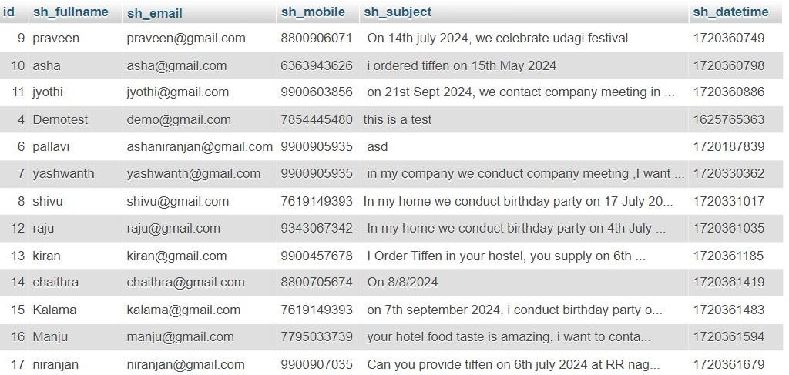

Figure5.1 Overview of Dataset

### Variable Information

In the context of a catering ordering system project, if we were to apply the selection sort algorithm to sort variables (such as order details or menu items), the focus would be on efficiently organizing and prioritizing these variables based on specific criteria.

In the context of the selection sort algorithm applied to a catering ordering system project, the variables typically refer to the data elements or entities that need to be sorted or managed within the system. Here are the key variables involved in the selection sort algorithm within this context:

* + - * **Orders**: Variables within an order might include order ID, customer details, delivery time, order items, and special instructions.
      * **Menu Items**: Variables associated with menu items include item name, description, category (e.g., appetizer, main course, desert),price, and availability status.
      * **Customer Preferences**: Variables can include dietary restrictions, preferred menu items, event- specific requirements (e.g., decorations, setup), and contact information.
      * **Inventory Items**: Variables include item name, quantity available, expiration date (if applicable), and location within inventory storage
      * **Employee Assignments**: Variables include employee ID, assigned tasks (e.g., cooking, packing, delivery), shift timings, and current status (e.g., available, busy).
      * **Event Details**: Variables may include event name, date, location, expected number of guests, and specific requirements outlined by the customer.

### Algorithm

* + 1. **Selection Sort Algorithm:**
       - The selection sort algorithm (SSA) is simple and can easily be implemented as compared to others such as the merge or quick sorting.
       - Selection sort operates directly on the input array without needing additional space (except for a few variables for indexing), making it an in-place sorting algorithm. This characteristic is beneficial when memory usage is a concern.

### STEPS:

The Selection sort algorithm follows a straightforward approach for classification:

1. **Initialization**: Start with an unsorted array of elements.
2. **Define ‘i’**: For each position ‘i’ from 0 to n-1.
   * Assume the element at index ‘i’ is the smallest (or largest) element for now.
3. **Find the minimum (or maximum) element in the unsorted portion**:
   * Iterate through the rest of the array from index i+1 to n-1 to find the smallest (or largest) element.
   * Keep track of the index of the minimum (or maximum) element found during this iteration.
4. **Swap elements**:
   * Swap the element at index i with the smallest (or largest) element found in step 3.
5. **Repeat**:
   * Repeat steps 2-4 for each subsequent index i until the entire array is sorted.
6. **End**: Once all elements are processed, the array will be sorted.
   1. **CODE :**

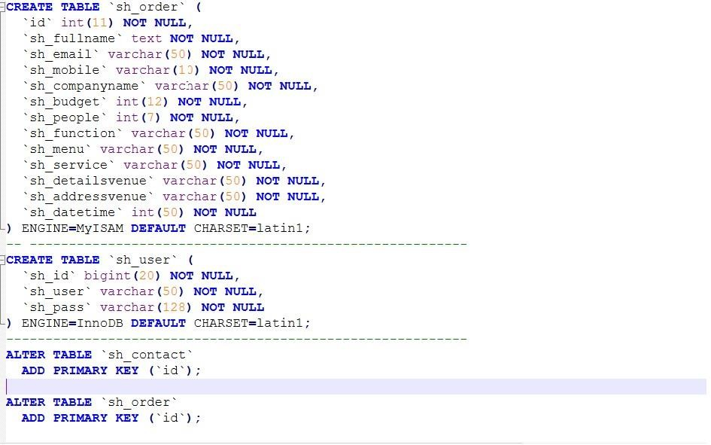

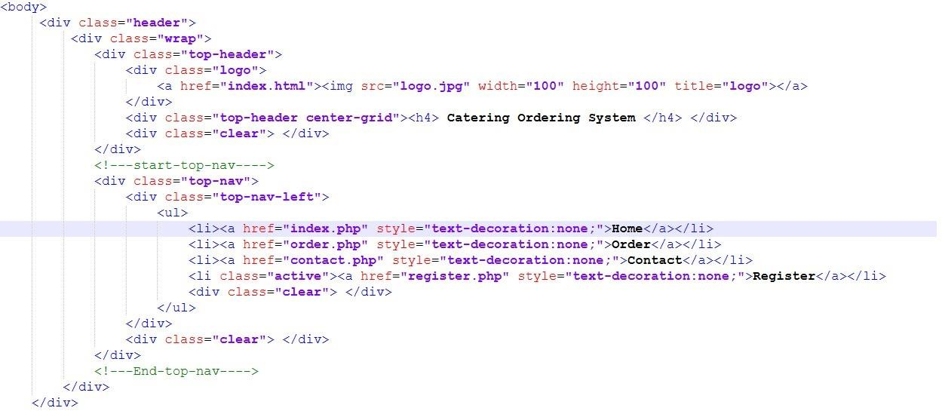

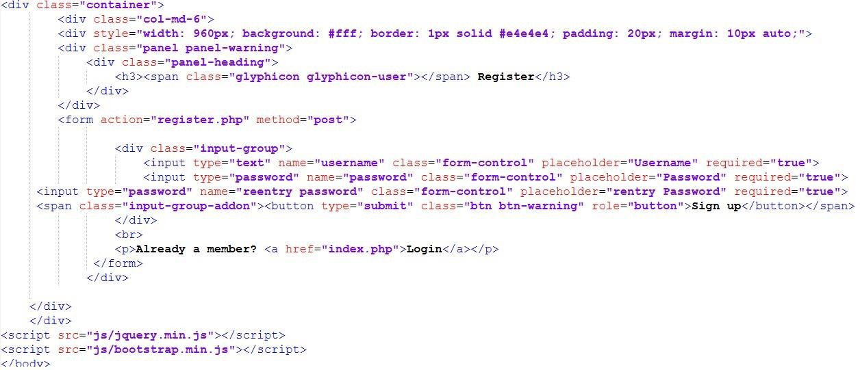

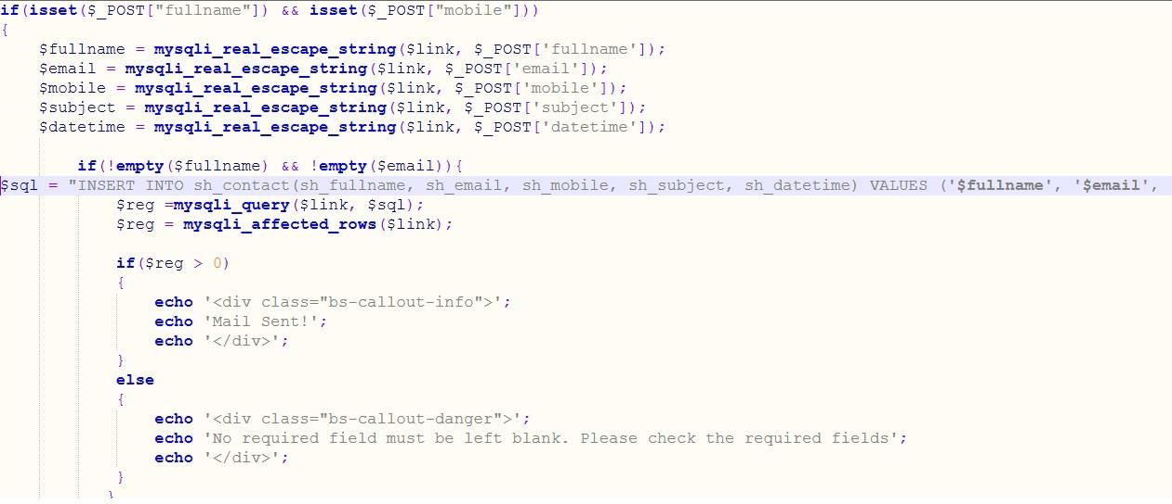

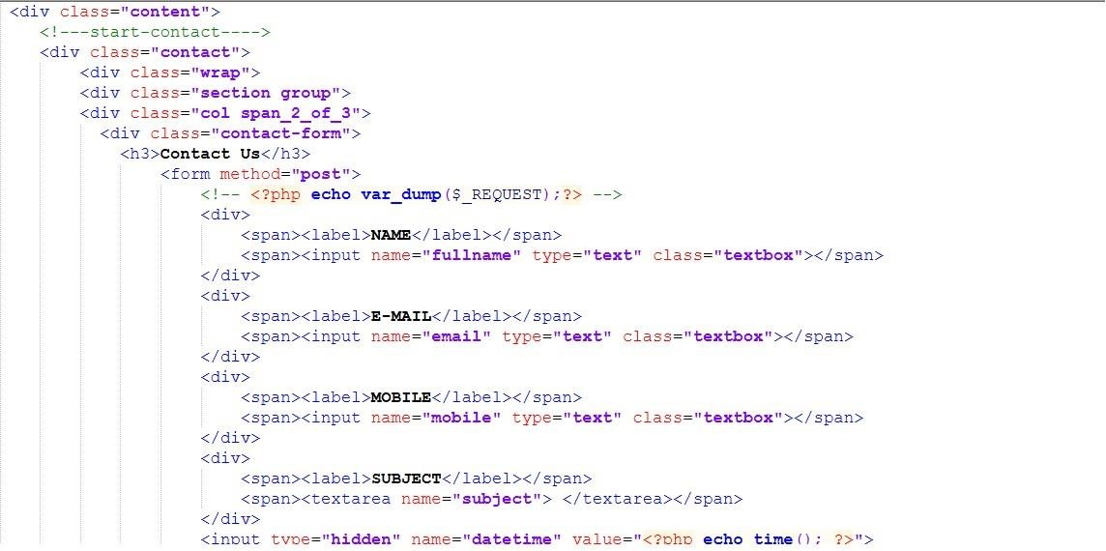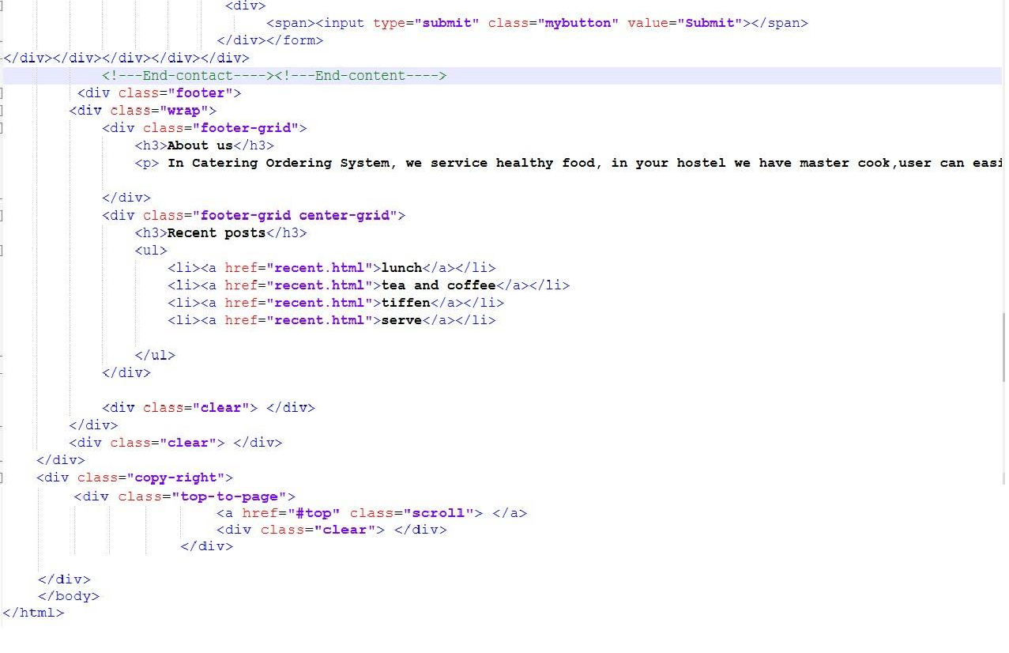

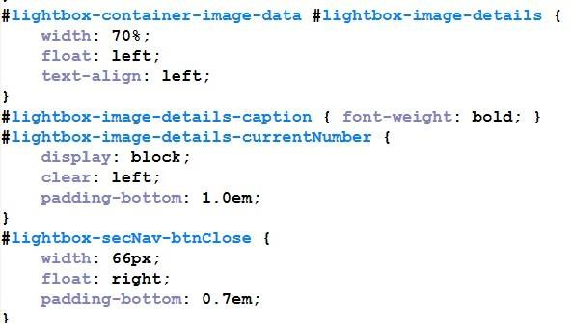

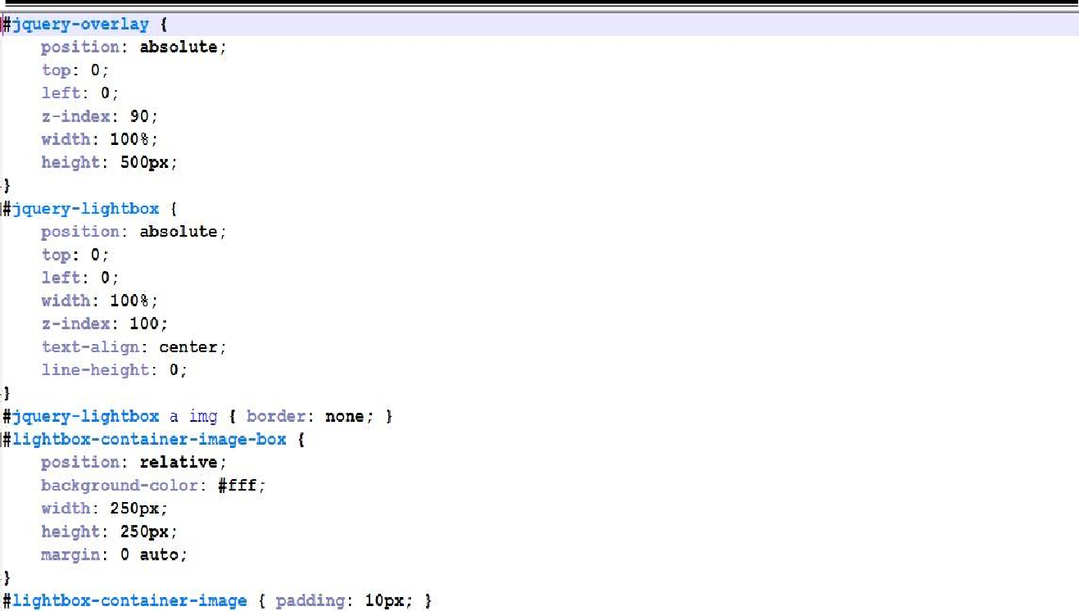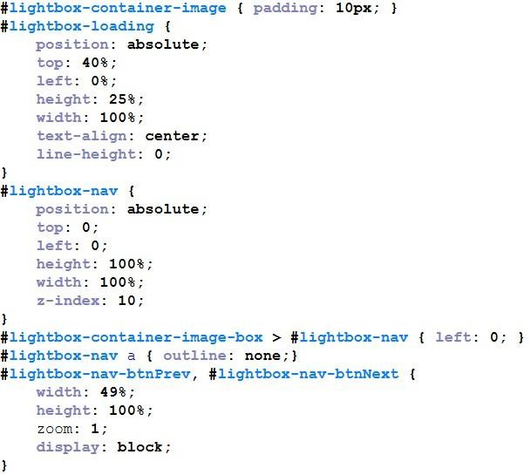

## CHAPTER 6

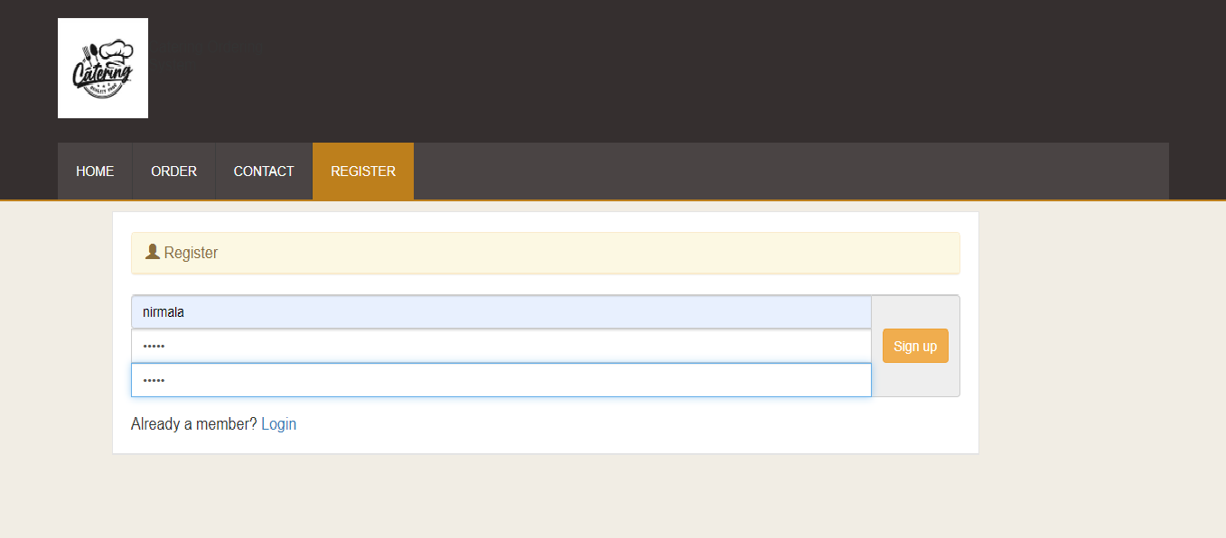**RESULTS**

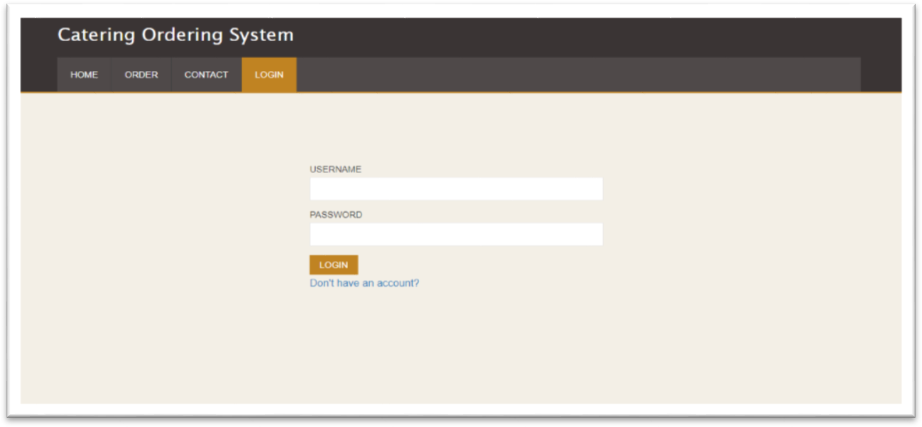Figure 6.1 :Admin Register page

Figure 6.2 : Admin Login page

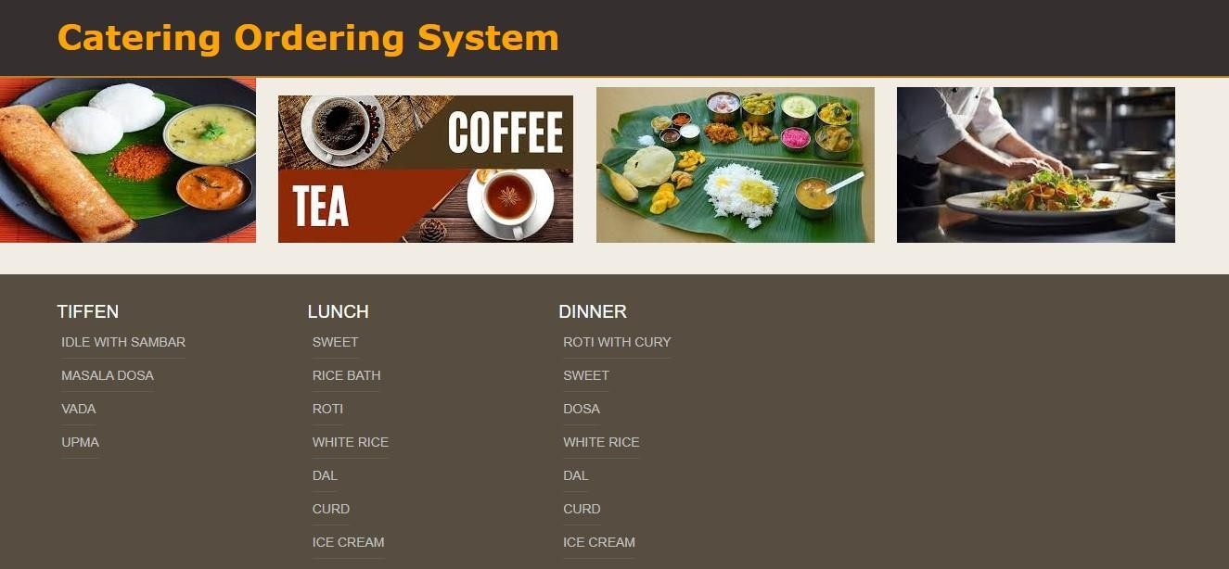

Figure 6.3: User Menu

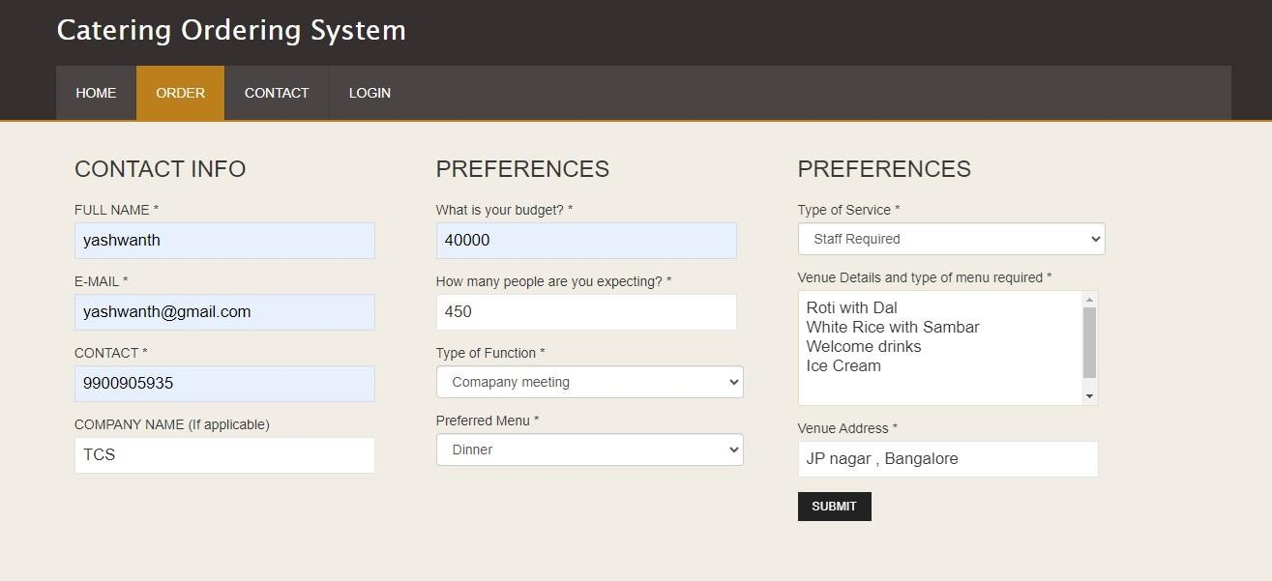

Figure 6.4 : User Order page

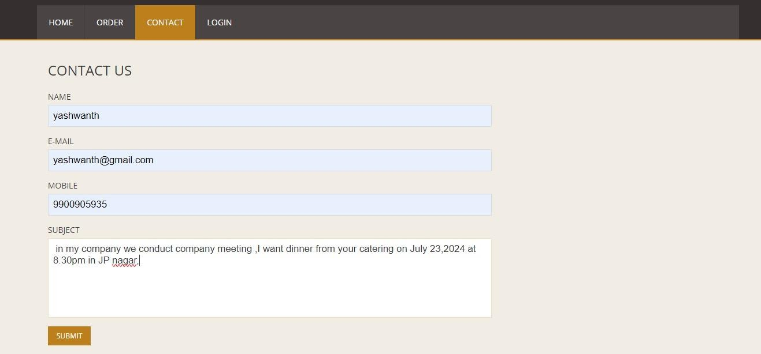

Figure 6.5: User Contact to admin

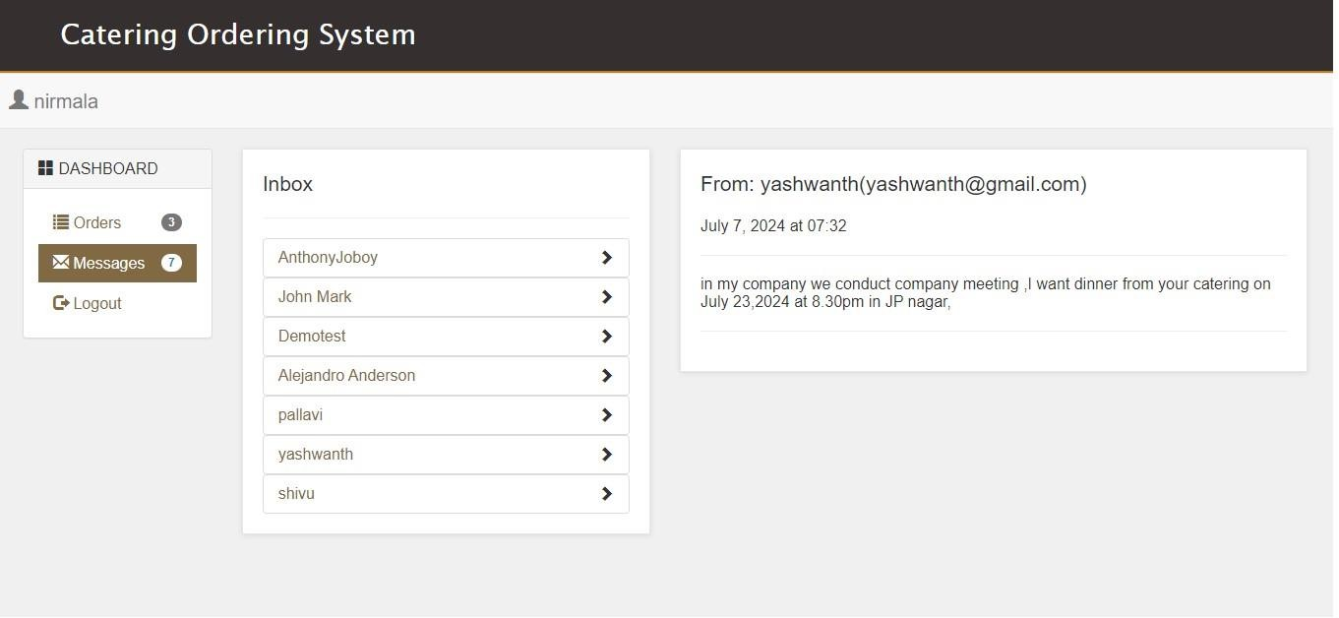

Figure 6.6: Admin Messages

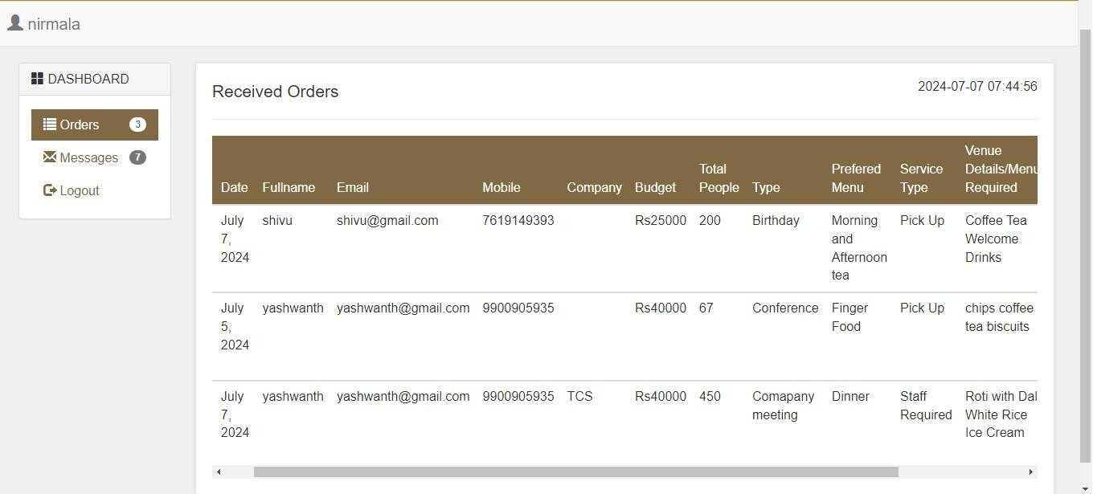

Figure 6.7: Admin Received Orders

**CHAPTER 7**

## CONCLUSION AND FUTURE ENHANCEMENTS

#### Conclusion

The catering ordering system project represents a significant achievement in streamlining the process of ordering and managing catering services. Through meticulous planning, development, and testing, we have created a robust platform that meets the diverse needs of customers, caterers, and administrators alike.

Selection Sort Algorithm has been integrated for development Catering Ordering System. The system consist several modules such as Customer module, Conduct Module and Admin Module. By taking advantage of the smartphone, computer devices and fast-paced Internet widespread use of access, it allows and easier for customers to search, booking and manage order efficiently. It makes customers convenience and the same time save cost and time. For the future, the new module will be implementing for decision making process to help the customers to find the Caterers based customers’ criteria.

**Future Enhancements:**

* In the future there will be more requirement by the user. Hence to meet the user requirements the software will be updated**,** Also after adding a new features to the new software a newer software version of the software will be developed hence also the software.
* **Blockchain for Supply Chain Transparency**: Utilizing blockchain technology to enhance transparency in the supply chain, ensuring food safety and traceability of ingredients from farm to table.
* **Multi-Language Support**: Adding support for multiple languages to cater to a diverse customer base and enhance accessibility for non-native speakers.
* **Enhanced Customer Support**: Integrating chatbots or AI-powered customer service agents to provide instant responses to customer queries, handle order inquiries, and resolve issues promptly.
* **Offline Ordering Capabilities**: Developing offline ordering capabilities for scenarios with limited internet connectivity, ensuring uninterrupted service during events or in remote areas.

## BIBLIOGRAPHY

#### 

* + **Mehta, D., Sahni, S., & Sanghi, D.** (2008). *Data Structures Using C and C++*. Universities Press.
  + **Sedgewick, R., & Wayne, K.** (2011). *Algorithms* (4th ed.). Addison-Wesley
  + Lei Zhou, Aichuan Wang, Yongxiang Zhang and Suodong Sun, 2004. A Smart Catering System Base on Internet-of-Things Technique. Communication Technology (ICCT), 2015 IEEE 16 International Conference on.
  + Zhou, M. and H. Wang, 2010. An efficient selection sorting algorithm for two- dimensional arrays. In Genetic and Evolutionary Computing (ICGEC), 2010 Fourth International Conference on , IEEE
  + Yang, Y., P. Yu and Y. Gan, 2011. Experimental study on the five sort algorithms. In Mechanic Automation and Control Engineering (MACE), 2011 Second International Conference on , IEEE.

#### 

Page | 19